**PROTOCOL**to laboratory exercise

***Negative Feedback***



|  |  |  |
| --- | --- | --- |
| Group / Class | Secretary | Signature |
| 5 / **4BHELS** | HOFSTÄTTER A. |  |
| Exercise- / Delivery date | Employee | Signature |
| 16. Dec. 2014  17. Dec. 2014 | BIEHL S. |  |
| Teacher | Employee | Signature |
| Tillich |  |  |
| Grade | Employee | Signature |
|  |  |  |
| ***Negative Feedback***  *BC546 & BC556* | | |
| **Used Devices**   |  |  |  |  |  | | --- | --- | --- | --- | --- | | Nr. | Device | Manufactor | Type | Place Nr. | | 1. | Function Generator | HAMEG | HM8030-6 | - | | 2. | Power Supply | Conrad | PS2403D | - | | 3. | Oscilloscope | Tektronix | TDS 1001B | - |   **Used Programs**   |  |  |  | | --- | --- | --- | | Nr. | Name | Version | | 1. | Altium Designer | 13 | | 2. | Micro-Cap | 11 | | | |

ÜBUNGS-/ABGABE-DATUM

Klasse /Gruppe

NOTE

LEHRER

# Table of Contents

1 Table of Contents 2

2 Tasks 3

2.1 Measurement Circuit 3

2.2 Given values 3

2.2.1 Assumptions 3

3 Calculation and Dimensioning 4

3.1 Needed Voltages 4

3.2 Resistors 4

3.3 Capacitors 4

4 Basic Measurements 5

4.1 Bias Voltages 5

4.2 Gain voltage 5

4.3 Voltage Capability 6

5 Bode Plot 8

5.1 Measured Values 8

5.2 Amplitude response () 9

5.3 Phase response 9

6 Input and output resistance and 10

6.1 Input resistance 10

6.1.1 Measurement setup 10

6.1.2 Measurement results 10

6.2 Output resistance 11

6.2.1 Measurement setup 11

6.2.1 Measurement results 11

7 Open loop gain 12

7.1 Measurement circuit 12

7.2 Measurement results 12

8 Simulation 13

8.1 Voltages and currents (Bias) 13

8.1.1 Voltages 13

8.1.2 Currents 13

8.2 Bode plot 14

8.2.1 Simulation Circuit 14

8.2.2 Simulation Setup 14

8.2.3 Simulation Results 15

9 List of Figures 16

# Tasks

Task of this laboratory exercise was to build a Two Stage Complementary Amplifier. This circuit is used to amplify the voltage based on the given gain.

1. Calculation, construction
2. Measurement of the BIAS voltage
3. Measurement of the gain and voltage capability.
4. Measurement and visualizing of the Bode Plot (Amplitude- and Phaseresponse)
5. Measuring of input and output resistance ()
6. Measurement of the Open Loop Gain

## Measurement Circuit

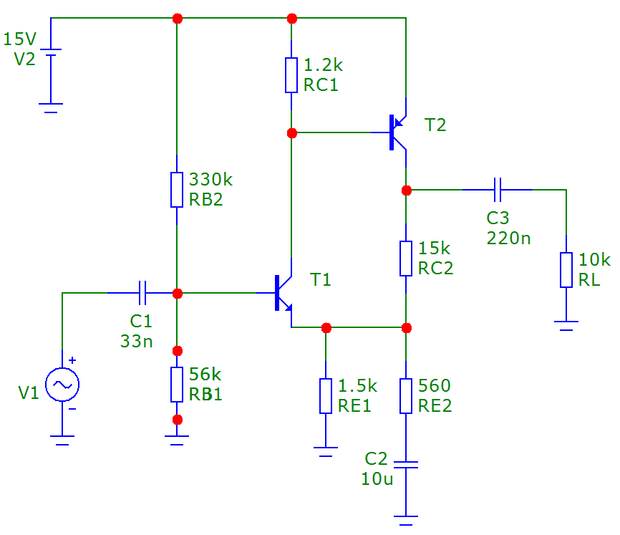

Figure 1 - Circuit of a two stage complementary amplifier

## Given values

The taken assumptions at point *2.2.1 Assumptions* were taken based on the following dependencies.

### Assumptions

|  |  |  |  |
| --- | --- | --- | --- |
|  |  |  |  |
|  |  |  |  |
|  |  |  |  |

Table 1 - Value Assumptions

# Calculation and Dimensioning

## Needed Voltages

## Resistors

Therefore that all needed voltages were assumed or calculated all resistors could be calculated now.

The formula for calculating the gain was converted to calculate , the last needed resistor.

To get a more accurate gain the resistor were chosen to be a smaller one, this would make a definite amplification of 30.

## Capacitors

For the following calculations the corner frequency was 100 Hz. Depending on real and available component values the next higher capacitor was choosen.

# Basic Measurements

## Bias Voltages

After final construction of the amplifier the bias voltages were measured. In this case the amplifier was operated with no input signal, so the operating point could be set and the bias voltages measured probably.

|  |  |  |
| --- | --- | --- |
|  | Calculated | Measured |
|  | 2.1 V | **2 V** |
|  | 1.5 V | **1.5 V** |
|  | 0.6 V | **0.6 V** |
|  | 0.6 V | **0.6 V** |
|  | 0.6 V | **0.6 V** |
|  | 6.75 V | **6.46 V** |
|  | 6.75V | **7.19 V** |
|  | 2.24 V | **2.13 V** |
|  | 12.9 V | **12.99 V** |

Table 2 - Calculated and measured Values of the bias voltages

As seen in above table the measured and calculated values are very similar. Some differences were noticed but these are based on parasitic errors and irregular and non-ideal components.

## Gain voltage

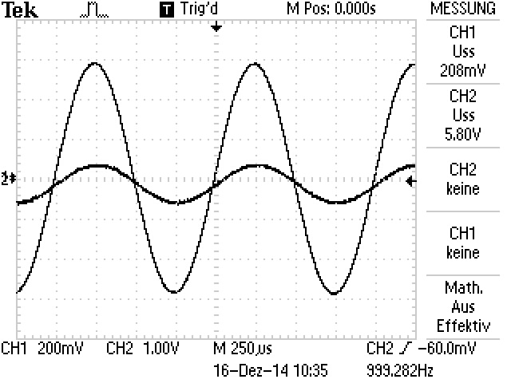

Figure 2 - Gain voltage

The amplifier was operated with an amplitude of , the measured output voltage was .

That implies that the gain is as assumed about 30.

In the gain voltage scope an amplification of can be seen instead of 30. A more accurate measurement result would be achieved with a lower . This would cause a bigger amplification.

## Voltage Capability

The voltage capability is about . Is the input voltage higher than this voltage the amplifier starts going in saturation.

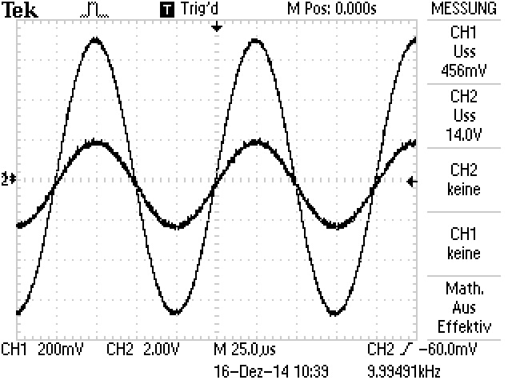

Figure 3 - Maximal voltage capability

With a higher input voltage () the output signal is already distorted. As seen in the following picture an amplitude of leads already to a saturation.

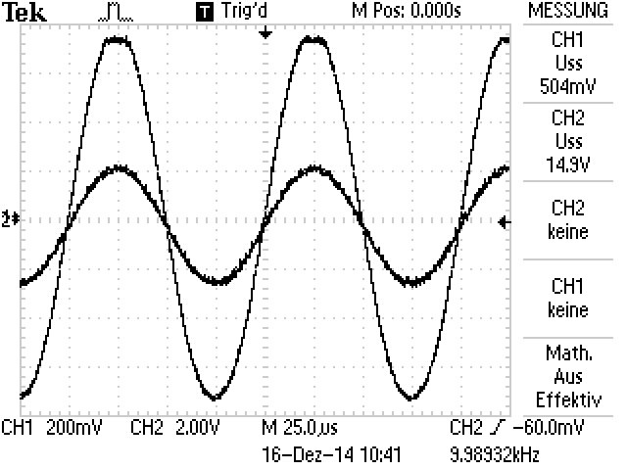

Figure 4 - Slightly distorted amplifier

With an amplitude of about , which is way too high for a normal and functional operation, the amplifier is heavy overmodulated and already on saturation.

With there is already a very steep rising rectangle signal at the output.

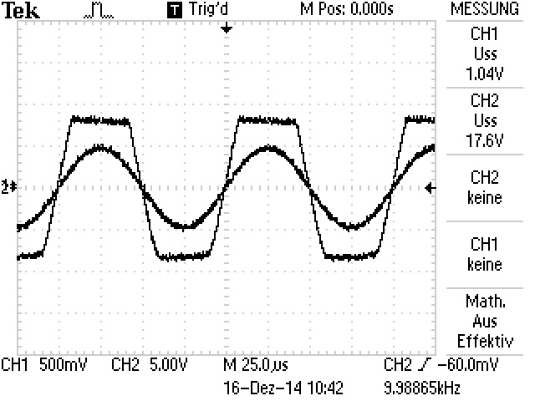

Figure 5 - Heavy distorted amplifier

# Bode Plot

The following three values (, and ) were measured with an oscilloscope by several multiple frequencies (20, 50, 100, 500, 1 000, 5 000, 10 000, 50 000, 1 000 000, 2 500 000 and 5 000 000) Hz

## Measured Values

|  |  |  |  |  |  |
| --- | --- | --- | --- | --- | --- |
|  |  |  |  |  |  |
| 20 | 0.181 | 0.7 | 11.7483893 | 12.08333333 | 87 |
| 50 | 0.181 | 1.8 | 19.9518786 | 2.2 | 39.6 |
| 100 | 0.181 | 3.38 | 25.4247625 | 0.27 | 9.72 |
| 500 | 0.181 | 5.2 | 29.1664954 | 0.022 | 3.96 |
| 1,000 | 0.181 | 5.3 | 29.3319459 | 0.0084 | 3.024 |
| 5,000 | 0.181 | 5.22 | 29.1998386 | 0.002 | 3.6 |
| 10,000 | 0.181 | 5.06 | 28.9294388 | 0.0008 | 2.88 |
| 5,000 | 0.181 | 5.02 | 28.8605028 | 0.0000534 | 0.9612 |
| 1,000,000 | 0.181 | 4.8 | 28.4712533 | 0 | 0 |
| 2,500,000 | 0.181 | 2.9 | 24.0943885 | -0.000024 | -21.6 |
| 5,000,000 | 0.181 | 1.7 | 19.4554069 | -0.000046 | -82.8 |

Table 3 - Bode plot measurement values

## Amplitude response ()

Figure 6 - Bode plot amplitude response

## Phase response

Figure 7 - Bode plot phase response

# Input and output resistance and

To measure the resistances of the amplifier, the input and output resistance, an additional extra circuit was built.

## Input resistance

### Measurement setup

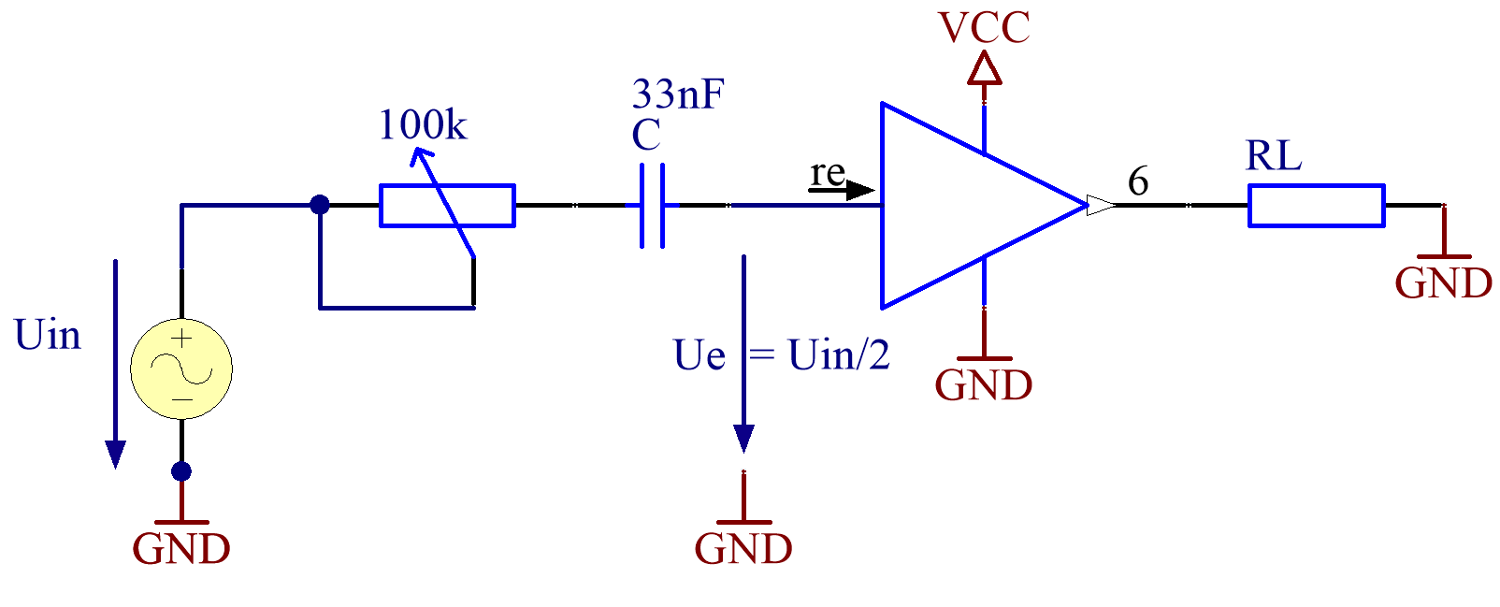

Figure 8 - Measurement circuit for the input resistance

### Measurement results

The circuit was operated with a functiongenerator and the parameters of 200 mV and a frequency of 10 kHz at the input of the amplifier.

The Potentiometer was changed until the measured voltage behind the capacitor was half of the voltage from the input signal. was measured behind the capacitor because otherwise a phase shift would exist.

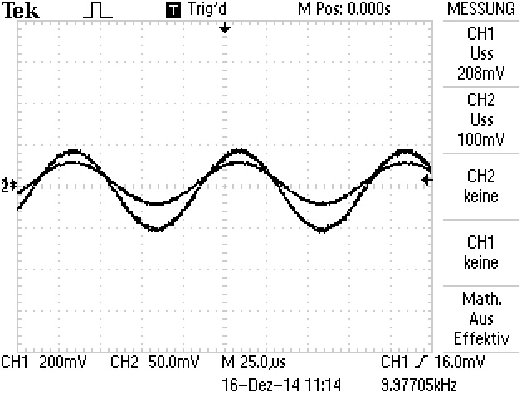

Figure 9 - Point where both voltages are the same

At the point where this happened () the finely adjusted resistance of the potentiometer had exactly the same value as the input resistance of the amplifier. The potentiometer had a measured resistance of . Therefore the following assertion for was made.

The so measrured value could be calculated approximately with .

The same measurement with an input frequency of resulted only in higher divergences. At the result for was which was much more inaccurate.

## Output resistance

### Measurement setup

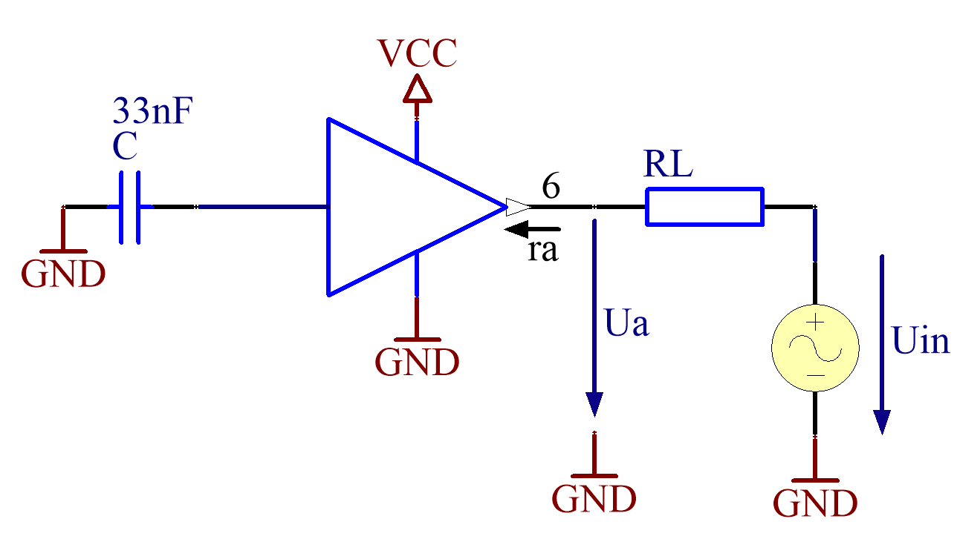

Figure 10 - Measurement circuit for the output resistance

### Measurement results

The circuit was operated with a functiongenerator and the parameters of 10 V and a frequency of 10 kHz at the output of the amplifier. The capacitor located at the input was shunt to ground.

The idea behind this measurement setup was to send a signal at the output into the amplifier. The voltage between output and load resistor was measured and for these voltage the following formula was effected and applicable. The measured value for was 92 mV.

# Open loop gain

To measure the open loop gain the circuit was a little bit adopted. First a voltage divider at the input was built, to make a very low input voltage (about 1 mV) possible. The voltage divider has a factor of 1:100 and therefore a 100 mV signal from the functiongenerator would affect an input signal of 1 mV at the amplifier input pin.

In addition to this the resistor was removed and the capacitor replaced with a Capacity.

With this modification the open loop gate could be measured with the voltage values of and .

## Measurement circuit

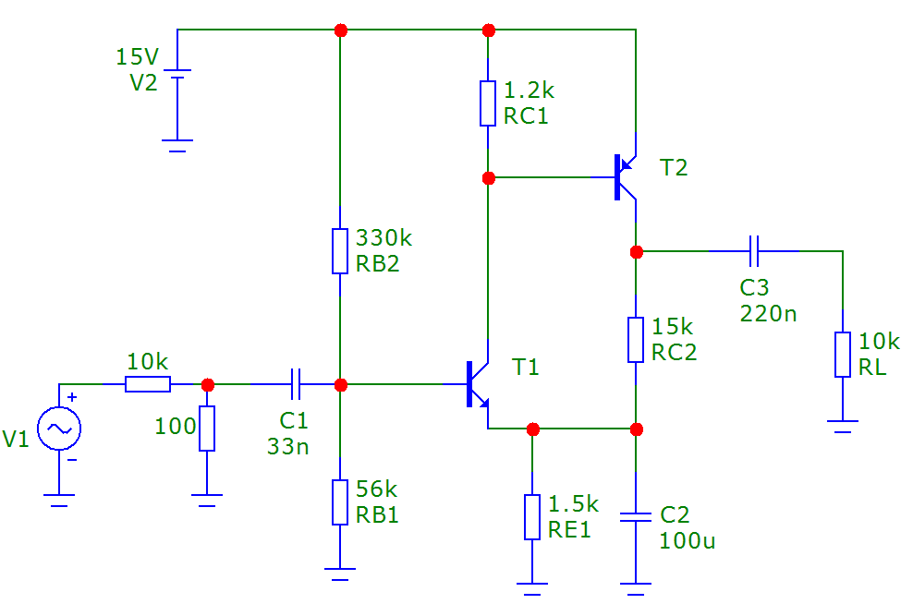

Figure 11 - Measurement circuit for the open loop gain

## Measurement results

Channel 1 was the voltage directly from the functiongenerator and the probe on channel 2 was connected to the amplifier output pin.

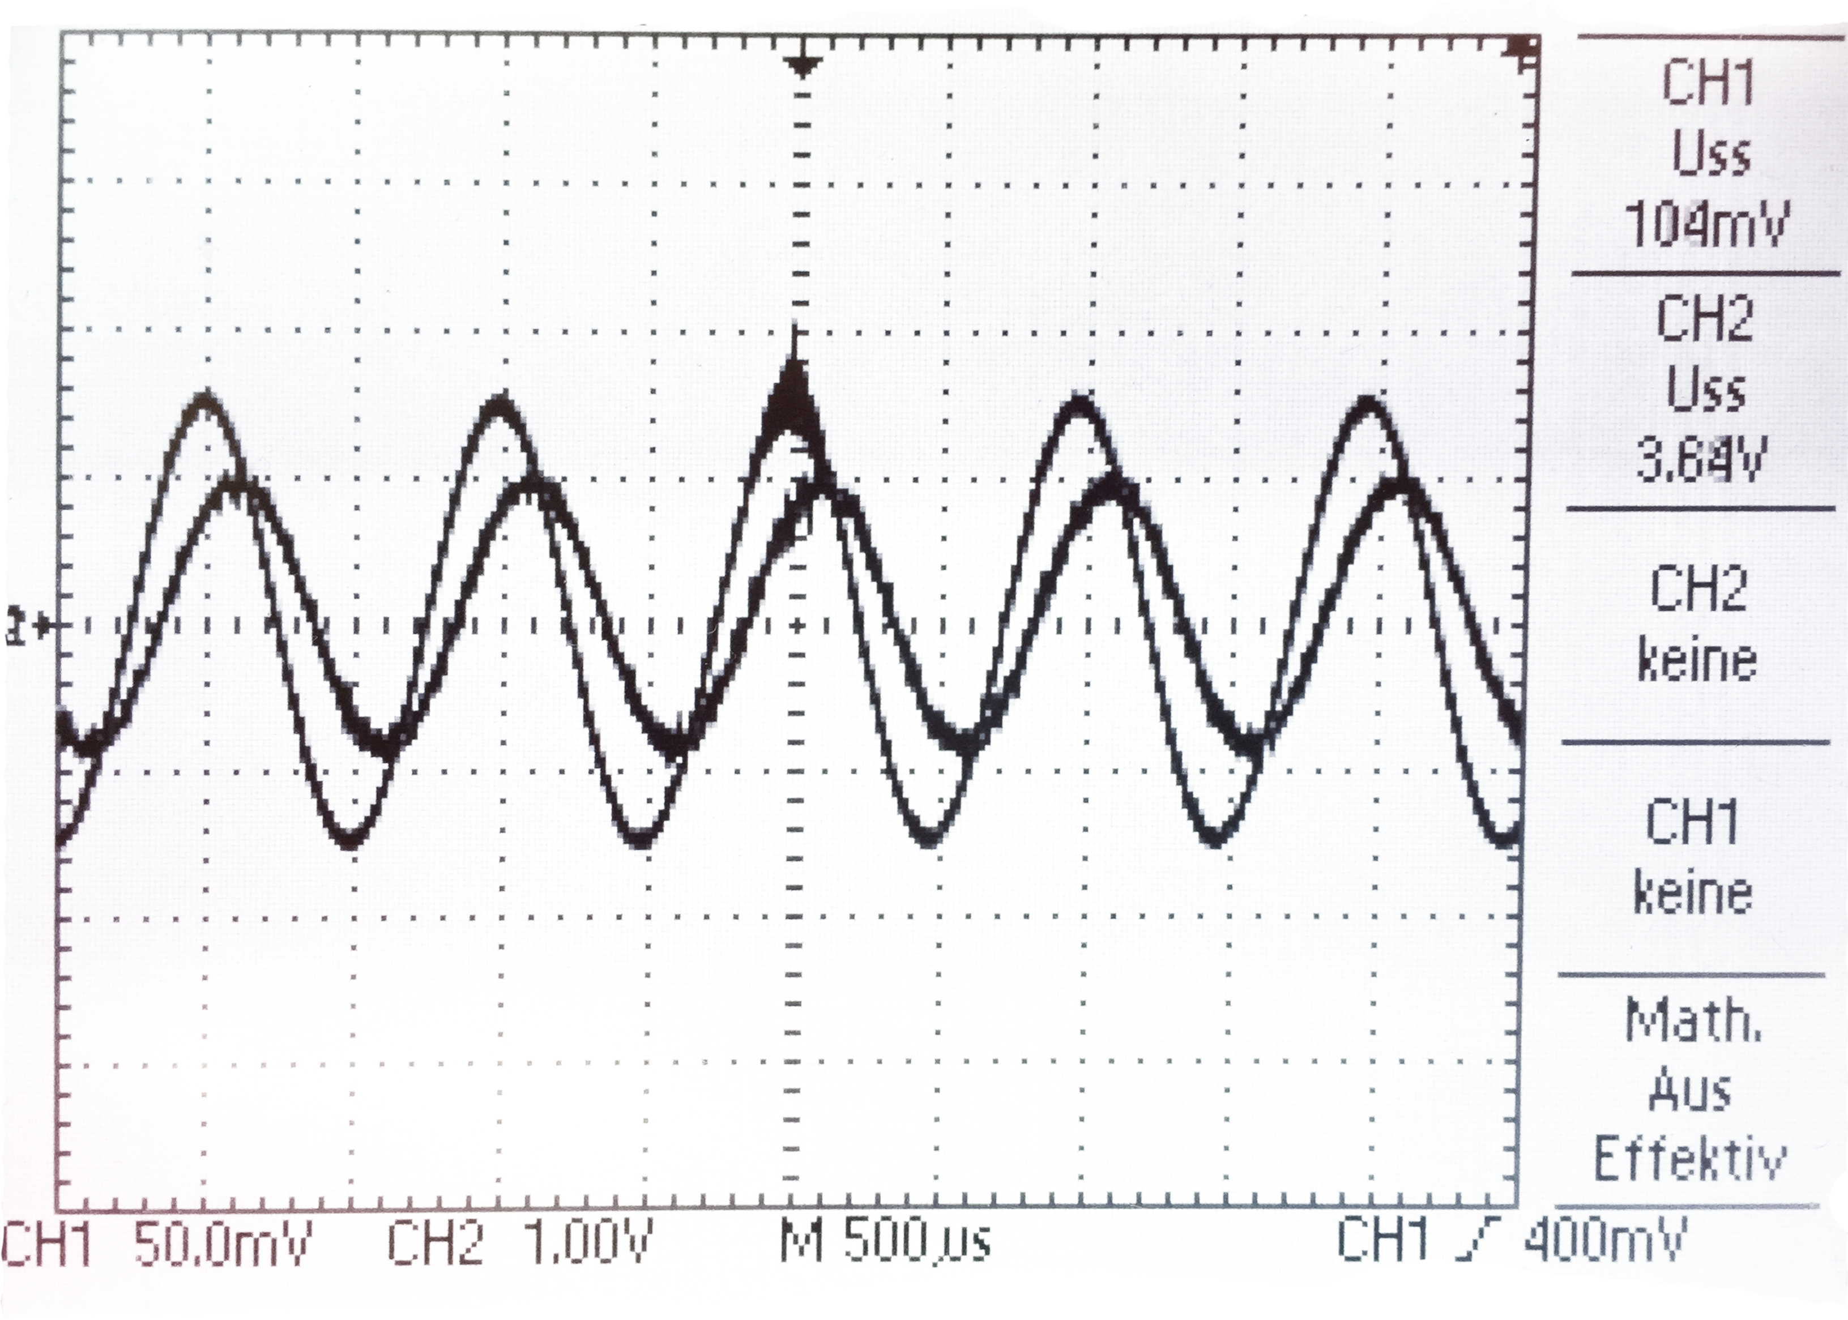

Figure 12 - Gain masurement for open loop

For correct calculations for the open loop gain the direct input voltage (behind the voltage divider) needs to be taken.

# Simulation

To simulate aboves already built circuit the same circuit was simulated in Micro-Cap to compare the simulations results with the measurement results.

## Voltages and currents (Bias)

### Voltages

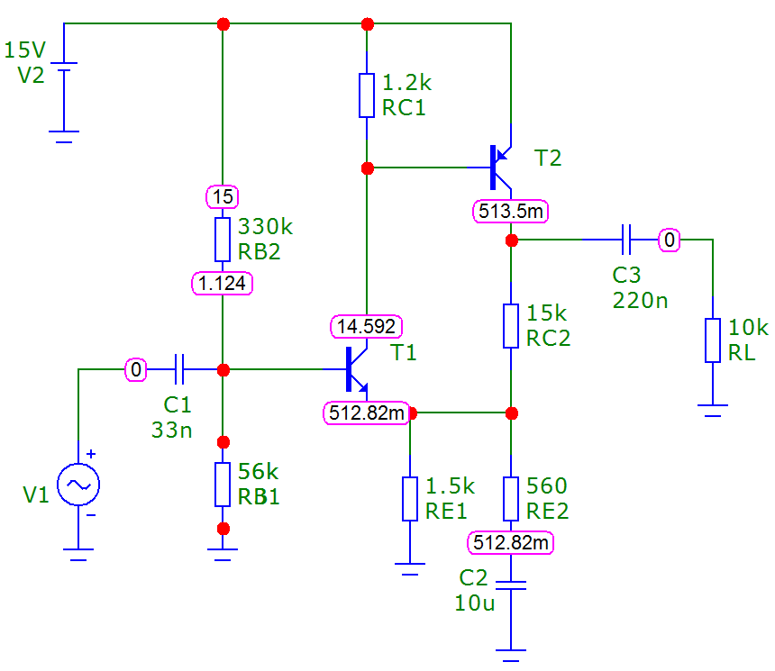

Figure 13 - Simulation of the bias voltages

### Currents

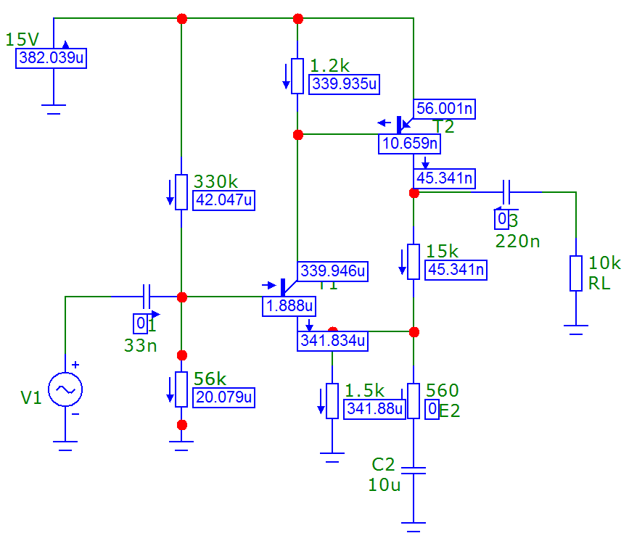

Figure 14 - Simulation of the bias currents

## Bode plot

### Simulation Circuit



Figure 15 - Simulation circuit of the bode plot

### Simulation Setup

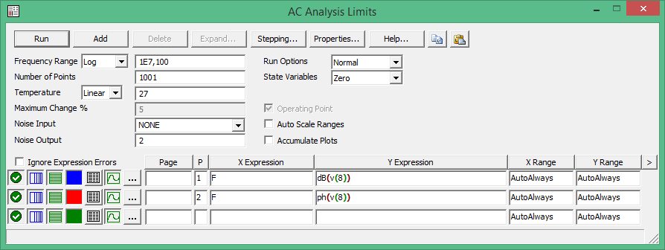

Figure 16 - Bode plot simulation settings

### Simulation Results

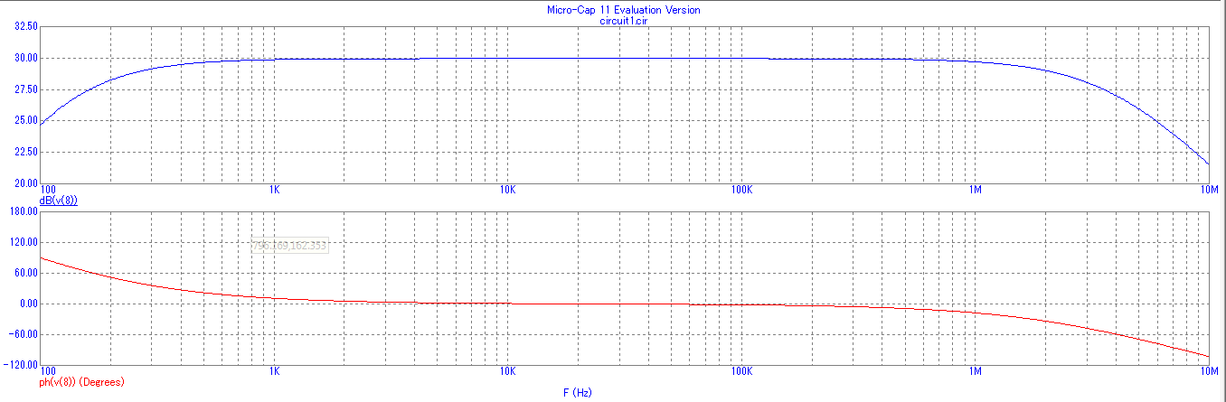

Figure 17 - Simulated bode plot in Micro-Cap

Finally can be seen that all realised simulations very similar if not even equal to the measured and calculated values were.

# List of Figures

Figure 1 - Circuit of a two stage complementary amplifier 3

Figure 2 - Gain voltage 5

Figure 3 - Maximal voltage capability 6

Figure 4 - Slightly distorted amplifier 6

Figure 5 - Heavy distorted amplifier 7

Figure 6 - Bode plot amplitude response 9

Figure 7 - Bode plot phase response 9

Figure 8 - Measurement circuit for the input resistance 10

Figure 9 - Point where both voltages are the same 10

Figure 10 - Measurement circuit for the output resistance 11

Figure 11 - Measurement circuit for the open loop gain 12

Figure 12 - Gain masurement for open loop 12

Figure 13 - Simulation of the bias voltages 13

Figure 14 - Simulation of the bias currents 13

Figure 15 - Simulation circuit of the bode plot 14

Figure 16 - Bode plot simulation settings 14

Figure 17 - Simulated bode plot in Micro-Cap 15